SCHOOL

Trial WACE Examination, 2010

Question/Answer Booklet

MATHEMATICS:
SOLUTIONS

SPECIALIST

3C/3D

Section Two:

Calculator-assumed

Student Number: In figures

In words

Your name

Time allowed for this section
Reading time before commencing work: 10 minutes
Working time for paper: 100 minutes

Material required/recommended for this section

To be provided by the supervisor
This Question/Answer booklet
Formula sheet (retained from Section One)

To be provided by the candidate
Standard items: pens, pencils, pencil sharpener, eraser, correction fluid, ruler, highlighters

Special items: drawing instruments, templates, notes on two unfolded sheets of A4 paper, and up to three calculators satisfying the conditions set by the Curriculum Council for this course.

Important note to candidates

No other items may be used in this section of the examination. It is your responsibility to ensure that you do not have any unauthorised notes or other items of a non-personal nature in the examination room. If you have any unauthorised material with you, hand it to the supervisor before reading any further.

Structure of this paper

Section | Number of questions available | Number of questions to be answered | Working time (minutes) | Marks available
Section One:  Calculator-free | 7 | 7 | 50 | 40
Section Two:  Calculator-assumed | 11 | 11 | 100 | 80
 |  |  |  | 120

Instructions to candidates

- The rules for the conduct of Western Australian external examinations are detailed in the Year 12 Information Handbook 2010. Sitting this examination implies that you agree to abide by these rules.

- Write your answers in the spaces provided in this Question/Answer Booklet. Spare pages are included at the end of this booklet. They can be used for planning your responses and/or as additional space if required to continue an answer.
- Planning: If you use the spare pages for planning, indicate this clearly at the top of the page.
- Continuing an answer: If you need to use the space to continue an answer, indicate in the original answer space where the answer is continued, i.e. give the page number. Fill in the number of the question(s) that you are continuing to answer at the top of the page.

- Show all your working clearly. Your working should be in sufficient detail to allow your answers to be checked readily and for marks to be awarded for reasoning. Incorrect answers given without supporting reasoning cannot be allocated any marks. For any question or part question worth more than two marks, valid working or justification is required to receive full marks. If you repeat an answer to any question, ensure that you cancel the answer you do not wish to have marked.

- It is recommended that you do not use pencil except in diagrams.

Section Two: Calculator-assumed (80 Marks)
This section has eleven (11) questions. Answer all questions. Write your answers in the space provided.

Working time for this section is 100 minutes.

Question 8 (5 marks)
A line and a plane are given by 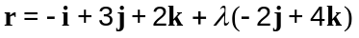 and 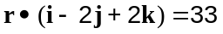.

(a) Find the position vector of the point of intersection of the line and plane. (2 marks)

Intersect when

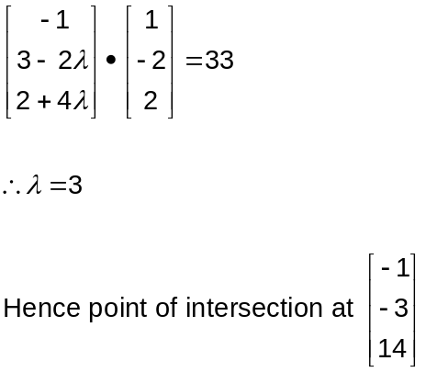

(b) Find the acute angle between the line and plane. (3 marks)
Find angle between line and normal to plane:

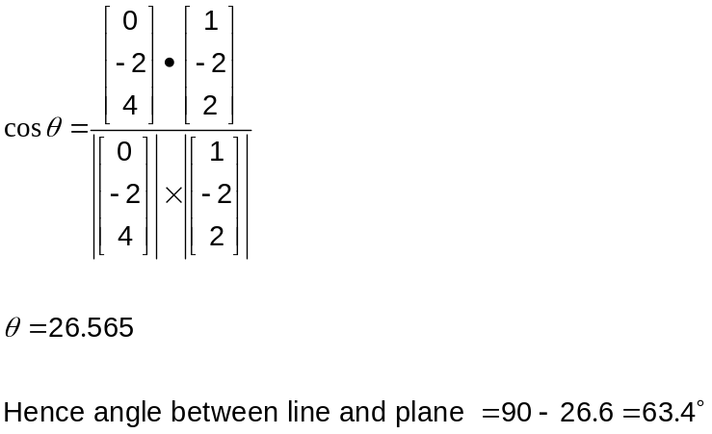

Question 9 (8 marks)
The quadrilateral with vertices A(0, 0), B(1, 2), C(-3, 1) and D(-2, -1) is transformed by the matrix 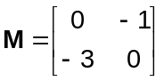 on to the quadrilateral A'B'C'D'.

(a) Determine the coordinates of A' and C'. (2 marks)
Origin invariant, so A'(0, 0).
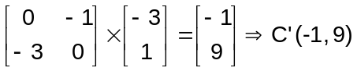

(b) The area of quadrilateral A'B'C'D' is 18 square units. What is the area of quadrilateral ABCD? (1 mark)
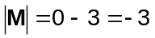
Area of ABCD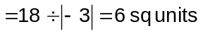

(c) Matrix M represents a combination of transformation P followed by transformation Q. If the matrix for transformation 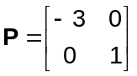, determine the matrix for transformation Q and describe the geometric transformation Q represents. (3 marks)
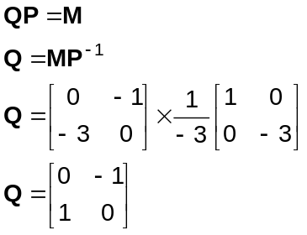

Q is a rotation of 90º anticlockwise about the origin.

(d) The quadrilateral A'B'C'D' then undergoes a shear of factor parallel to the x-axis such that the image of C' lies on the y-axis. Determine the value of . (2 marks)
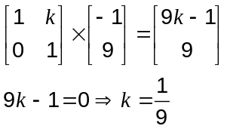

Question 10 (7 marks)
Sketch the following regions in the complex plane.

(a) 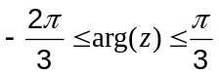. (2 marks)
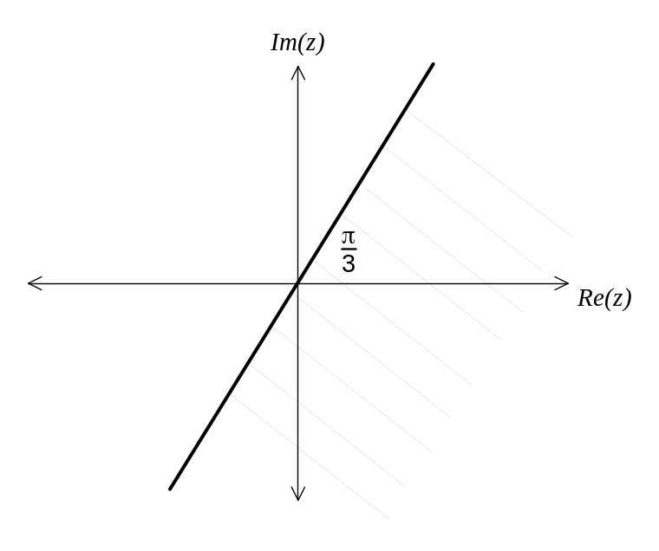

(b) 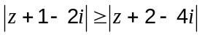. (3 marks)
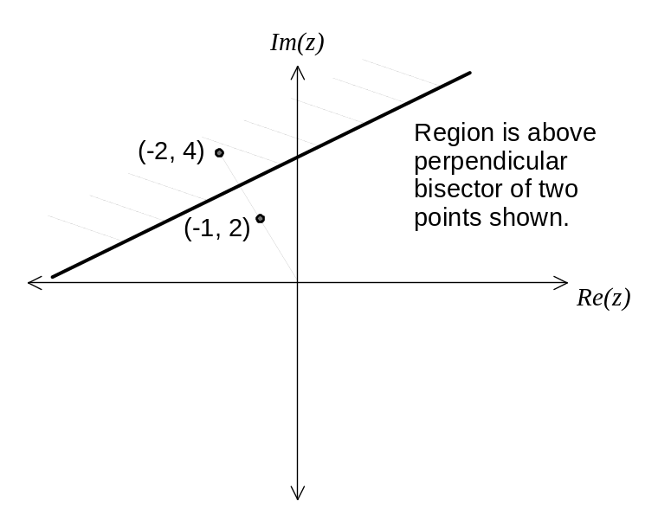

(c) For the region in (b) above, state the minimum value of 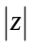. (2 marks)
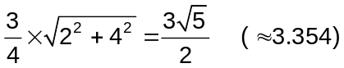

Question 11 (6 marks)
(a) A curve is defined parametrically as 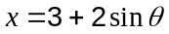 and 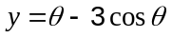. Find the equation of the tangent to the curve when 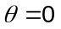. (3 marks)
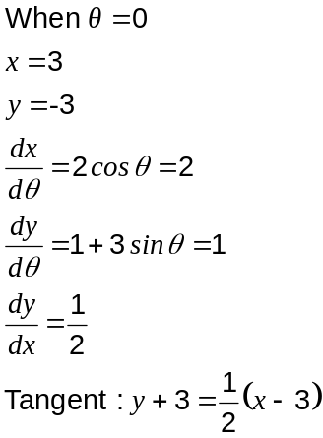

(b) Using the substitution 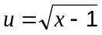, the definite integral 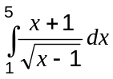 can be written as 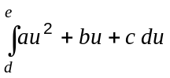. Find the value of the constants , , , and . (3 marks)

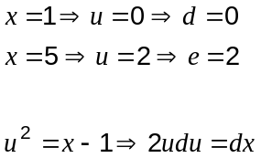

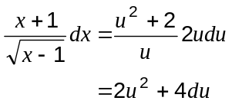

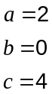

Question 12 (7 marks)
A moving part in a machine slides along a straight rod with velocity 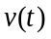cm/s as shown in the graph below, where 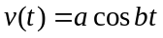, and both constants.
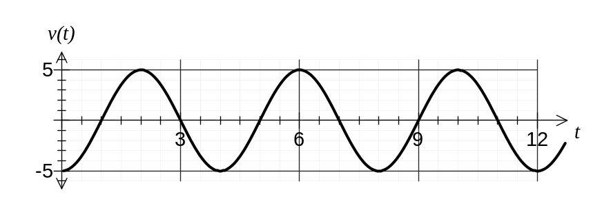
(a) If 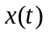locates the position of the moving part relative to a fixed point on the rod, and given that 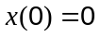, determine an equation for . (3 marks)
From graph, 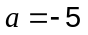 and 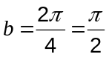.

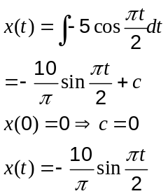

(b) Determine the maximum magnitude of acceleration experienced by moving part and when this first occurs for 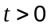seconds. (2 marks)
Part moving with SHM
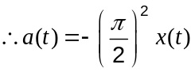
Acceleration max when displacement max (velocity is zero)
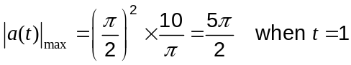

(c) Find the distance travelled by the moving part in the first 9 seconds. (2 marks)
In first 9s, part will travel 9 complete quarter cycles.
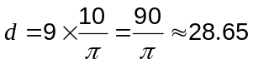cm.

Question 13 (9 marks)
A researcher is modelling the size of a fruit bat colony in a protected area. Age-specific female survival (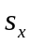) and breeding (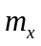) rates are shown in the table below, as well as the female population structure (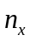) when the study began.

Age () in months | 0-6 | 6-12 | 12-18 | 18-24
Female population () | 60 | 150 | 80 | 15
Half-yearly female breeding rate () | 0.0 | 1.4 | 1.2 | 0.6
Half-yearly female survival rate () | 0.4 | 0.7 | 0.4 | 0.0

The researcher used a Leslie matrix model of the form 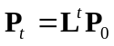 to examine the female population distribution after t six-month intervals.

(a) Write down the coefficient matrices  and 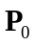. (2 marks)
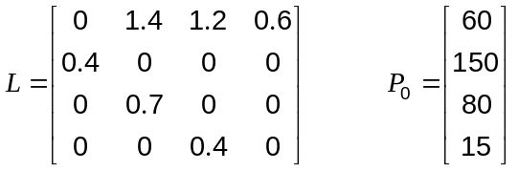

(b) By how many did the number of female fruit bats increase six months after the study began according to this model? (2 marks)
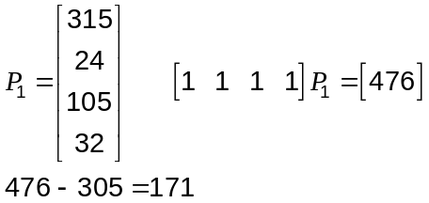

An increase of 171 fruit bats.

(c) Estimate the female fruit bat population predicted after 3 years. (1 marks)

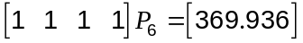

370 fruit bats.
(d) After 9 years, what percentage of the female population are breeding females? (2 marks)

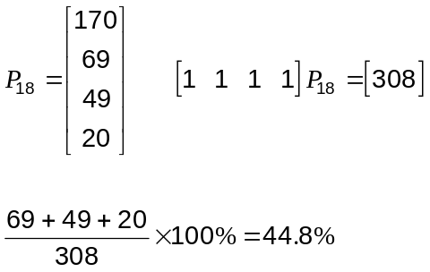

(e) The researcher is confident that the survival rate for 0-6 month old fruit bats can be increased from 40% to 45%. Comment on the effect that this will have on the long-term population of fruit bats predicted by this model. (2 marks)
With current model, the fruit bats are slowly decreasing in numbers as time goes on.

By increasing the stated survival rate, this trend is reversed and the long term population will increase.

Question 14 (8 marks)
The temperature in a restaurant cool room is set to 4C. One day, the refrigerator unit was turned back on after the temperature in the cool room had risen to 27C due to cleaning and maintenance work. After 15 minutes, the temperature in the cool room had dropped to 11C, with the temperature, , falling according to the model
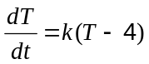
where is the time in minutes since the refrigerator unit was turned back on.

(a) Find the value of and express as a function of . (5 marks)
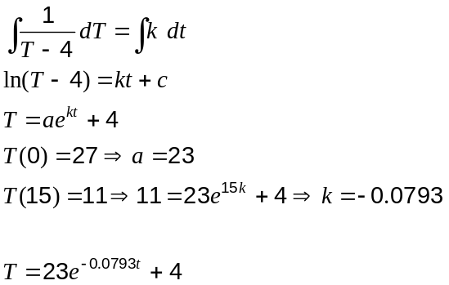

(b) If the temperature continues to fall in this way, how long before the temperature in the cool room registers 4C, to the nearest degree? (3 marks)
Temperature must drop to 4.5C

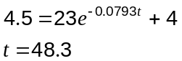

After 48.3 minutes.

Question 15 (7 marks)
A remote controlled movie camera moves along a length of straight track. During one nine second recording of an action sequence, the initial position of the camera was 70 metres in the positive direction from a fixed point O and at this time it was moving with a velocity of 43 metres per second. The camera experienced an acceleration given by 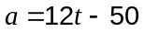m/s², where was the time in seconds since the recording began.

In the questions below, consider only the interval 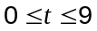.

(a) Determine the time(s) that the camera was at the origin. (3 marks)
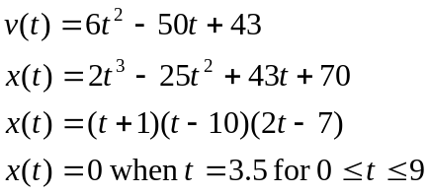

(b) What was the maximum distance that the camera was from O? (1 mark)
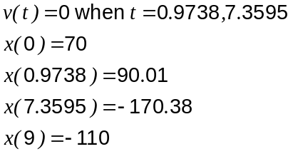 Hence max distance is 170.38m

(c) How far did the camera travel between the times that its velocity was a minimum and a maximum, correct to the nearest centimeter? (3 marks)
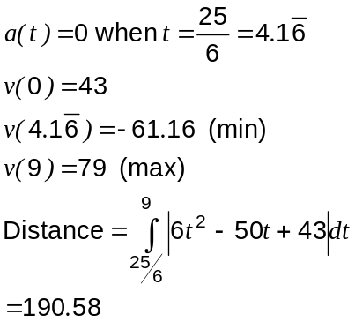

Question 16 (10 marks)
A body, A, has an initial position of 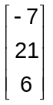 metres and is moving with a constant velocity of 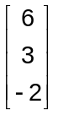 metres per second.

(a) A second body, B, is moving with constant velocity of 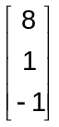 metres per second and collides with body A after six seconds.

Determine the initial distance apart of body A and body B. (4 marks)

A and B collide at
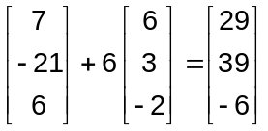

Hence initial position of B is at
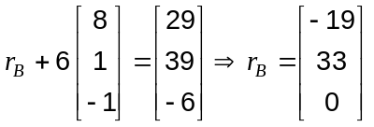

Distance apart of A and B is
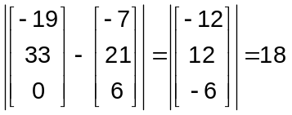

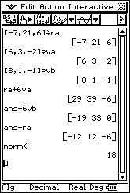

(b) A third body, C, is initially located at 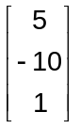 metres and is also moving with a constant velocity 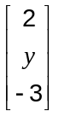. After five seconds, the distance between bodies A and C is a minimum.

Find the value of for which the speed of C is also a minimum. (6 marks)

Let and be velocity and displacement of A relative to C

Then minimum distance apart when and 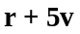 are perpendicular, ie the dot product of and is zero.

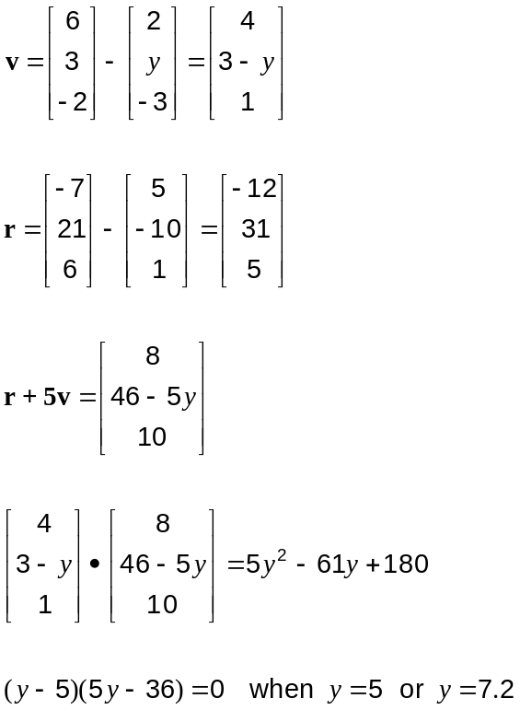

Hence for 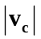 to be a minimum, 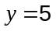.

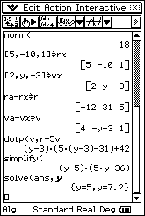

Question 17 (6 marks)
Given the identity , prove by induction that for integers 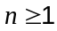,
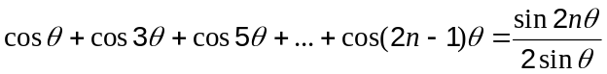.

When 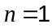, statement is true

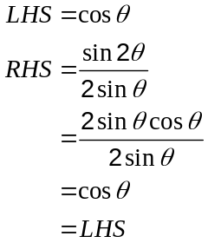

Assume statement true for 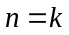, that is
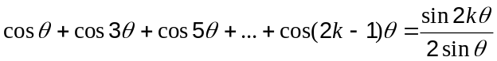

When 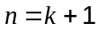
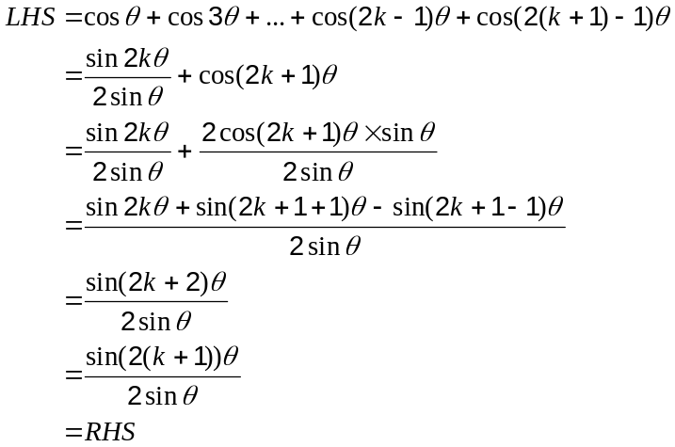

Hence if statement is true for then the statement is also true for .

Since statement is true for , then statement always true for .

Question 18 (7 marks)
A video camera, located on an overhead gantry 10.8m above the surface of a level freeway, is tracking the front licence plate of a car driving directly towards it at 135km/h. The camera automatically adjusts its angle of depression so that it is always pointing directly at the centre of the licence plate, which in this case is 30cm above the ground.

Find the rate at which the angle of depression of the camera is changing when the front of the car is 36m from a point directly beneath the video camera.
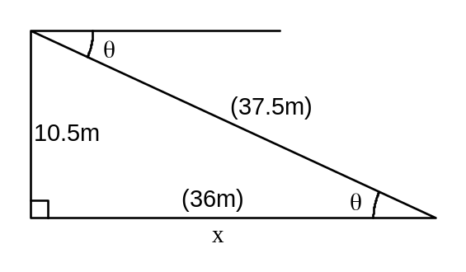

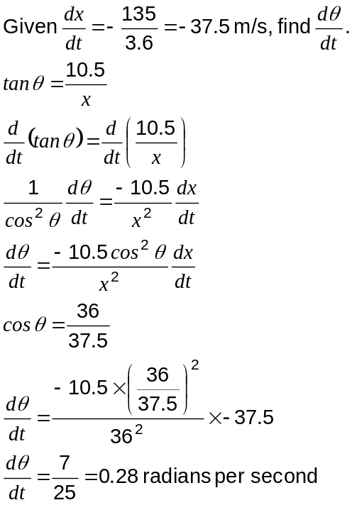

Additional working space

Question number(s):

